38. Face Detection Using OpenCV
Aim
To detect human faces in an image using OpenCV and Haar Cascade Classifier.
Algorithm
- Import the OpenCV library.
- Load the input image.
- Convert the image into grayscale.
- Load the Haar Cascade face detector.
- Detect faces using detectMultiScale().
- Draw rectangles around the detected faces.
- Display the output image.
Python Program
import cv2
# Load the image
image = cv2.imread("face.jpg")
# Convert image to grayscale
gray = cv2.cvtColor(image, cv2.COLOR_BGR2GRAY)
# Load Haar Cascade Classifier
face_cascade = cv2.CascadeClassifier(
cv2.data.haarcascades + "haarcascade_frontalface_default.xml"
)
# Detect faces
faces = face_cascade.detectMultiScale(
gray,
scaleFactor=1.1,
minNeighbors=5,
minSize=(30, 30)
)
# Draw rectangles around faces
for (x, y, w, h) in faces:
cv2.rectangle(
image,
(x, y),
(x + w, y + h),
(0, 255, 0),
2
)

# Display result
cv2.imshow("Face Detection", image)

cv2.waitKey(0)
cv2.destroyAllWindows()
Output
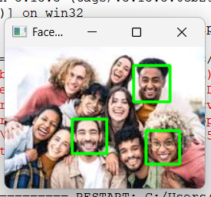
Result
Thus, the human faces in the given image were successfully detected using OpenCV Haar Cascade Classifier.

